My Sensory Passport
Name: DoB:

Date created: School/Class:

My Sensory Likes:
The things that bring me joy My special interests Favourite smells
Favourite things to touch Preferred foods
The things I seek more of

My best learning environment:

My Sensory Challenges:
The things that I struggle with The smells that make me feel ill The noises that bother me
My movement needs
The textures I find uncomfortable The environments I find challenging

Sensory supports that can help me:
Important to know!

When I am feeling dysregulated I might show this through:
Running away Leaving the classroom
Kicking or hitting my peers Kicking or hitting adults Spitting
Biting Pacing Crying
Withdrawing/ shutting down I might freeze and zone out

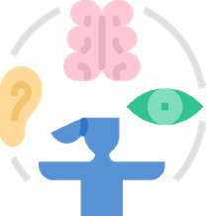
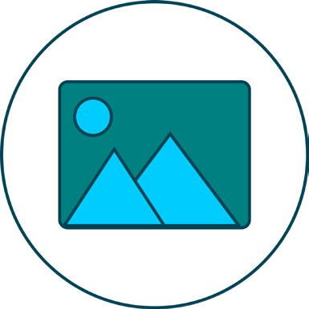
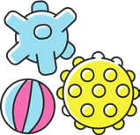
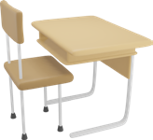




The strategies that can be used to help me learn What I might need in the school classroom Seating
Lighting
Visual distraction Sensory circuits Movement opportunities Noise levels
Navigating the environment Visual time tables
Calm space Sensory circuits Visual time tables Sensory box Weighted object Movement breaks Chew
Snacks
Prompts for toileting Zones of regulation
Please help me to regulate by:
Don’t try to engage me in conversation or ask me to make good choices.
Direct me to a safe space
Give me lots of space and don’t come near to me Give me access to my sensory toolkit
Let me spend time in my sensory den Let me run into the hall
Offer me a snack and/or a drink
Offer me my comfort item and weighted blanket

