______________________’s sensory profile
Sensory System | Preferences  Experiences the child likes or enjoys | Challenges  Things that challenge the child or challenge you as a caregiver / practitioner / teacher
Tactile 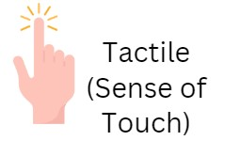
Vestibular 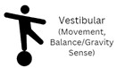
Proprioception


Auditory
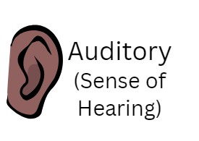
Taste

Olfactory
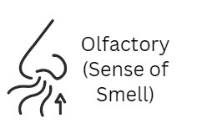
Visual

Choose 3-4 priority challenges to address. Taking into account the child’s sensory preferences, use the suggested strategies documents to identify any modifications to the environment, strategies to use and activities to build into the child’s day to help meet their sensory needs.

