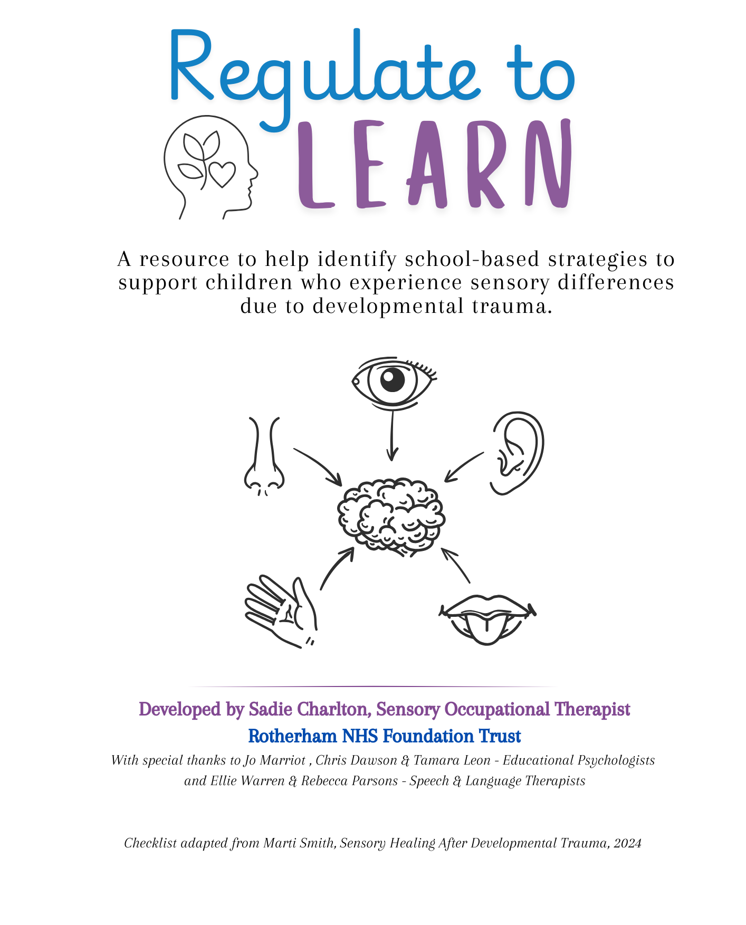

Contents

- Background to the toolkit

- Regulate to Learn Framework

- An introduction to our senses

- Sensory Seeking or Seeking Safety?

- Stressors

- Under-developed Sensory Systems

- Interoception & Trauma

- Trauma-Compassionate Approach

- Neurodiversity & Trauma

- How to use this toolkit

- Useful Resources

Appendix 1 – Trauma-informed Sensory Checklist

Appendix 2 – Safety, Senses & Belonging Profile

Appendix 3 – Regulate to Learn Passport

Background to the toolkit
The idea for the Regulate to Learn Toolkit first developed within Virtual School Rotherham as part of their Sensory OT pilot initiative. During this work, it became clear that many children looked after were struggling with school engagement and learning due to unmet sensory needs linked to early adversity and trauma. Schools were often unsure how to recognise these needs or what practical strategies might help. Developed in collaboration with Virtual School Rotherham (Early Years & Primary), whose commitment to addressing the sensory needs of children looked after laid the foundation for its creation, this toolkit was designed to provide staff and carers with a clear, accessible resource to notice sensory differences, respond in a trauma-informed way, and remove barriers to learning. Special thanks to Head Teacher Tina Hohn and the Virtual School Education Advisors for Early Years and Primary, whose advocacy and support played a key role in shaping the development of this resource.
Understanding sensory processing is vital for anyone supporting children who have experienced developmental trauma or early adversity. These experiences can shape how children take in and respond to the world around them, influencing their ability to feel safe, regulate emotions, and engage in learning.
Sensory processing describes how the nervous system receives, interprets and responds to information from the senses. Alongside sight, hearing, taste, smell and touch, three additional senses are essential:
- Proprioception – awareness of body position and movement
- Vestibular – balance and spatial orientation
- Interoception – awareness of internal bodily signals such as hunger, thirst or the need to use the toilet
When these systems have been affected by trauma or adversity, children may seek out sensory experiences that bring comfort and predictability, or avoid those that feel overwhelming. Each child’s responses are unique, shaped by both their biology and their lived experience.
For children with a history of trauma, sensory challenges can have a significant impact on everyday routines, emotional wellbeing, relationships, and their ability to take part fully in school life. Creating supportive environments- considering factors such as noise, lighting and classroom layout– can help children feel safer and more regulated, increasing their capacity to focus, connect and learn.
The Regulate to Learn Toolkit has been developed as a practical, trauma-informed resource for teachers, designated teachers, SENDCos and professionals working with vulnerable children. It is not a formal assessment tool, but a guide to help staff recognise potential sensory needs, put early strategies in place, and use this understanding to inform planning and support.
At its heart, this toolkit encourages a compassionate and relational approach, helping adults to interpret sensory behaviours in the context of a child’s experiences. By drawing on the strategies within, schools and caregivers can begin to reduce barriers to learning, strengthen relationships, and foster healing and resilience.
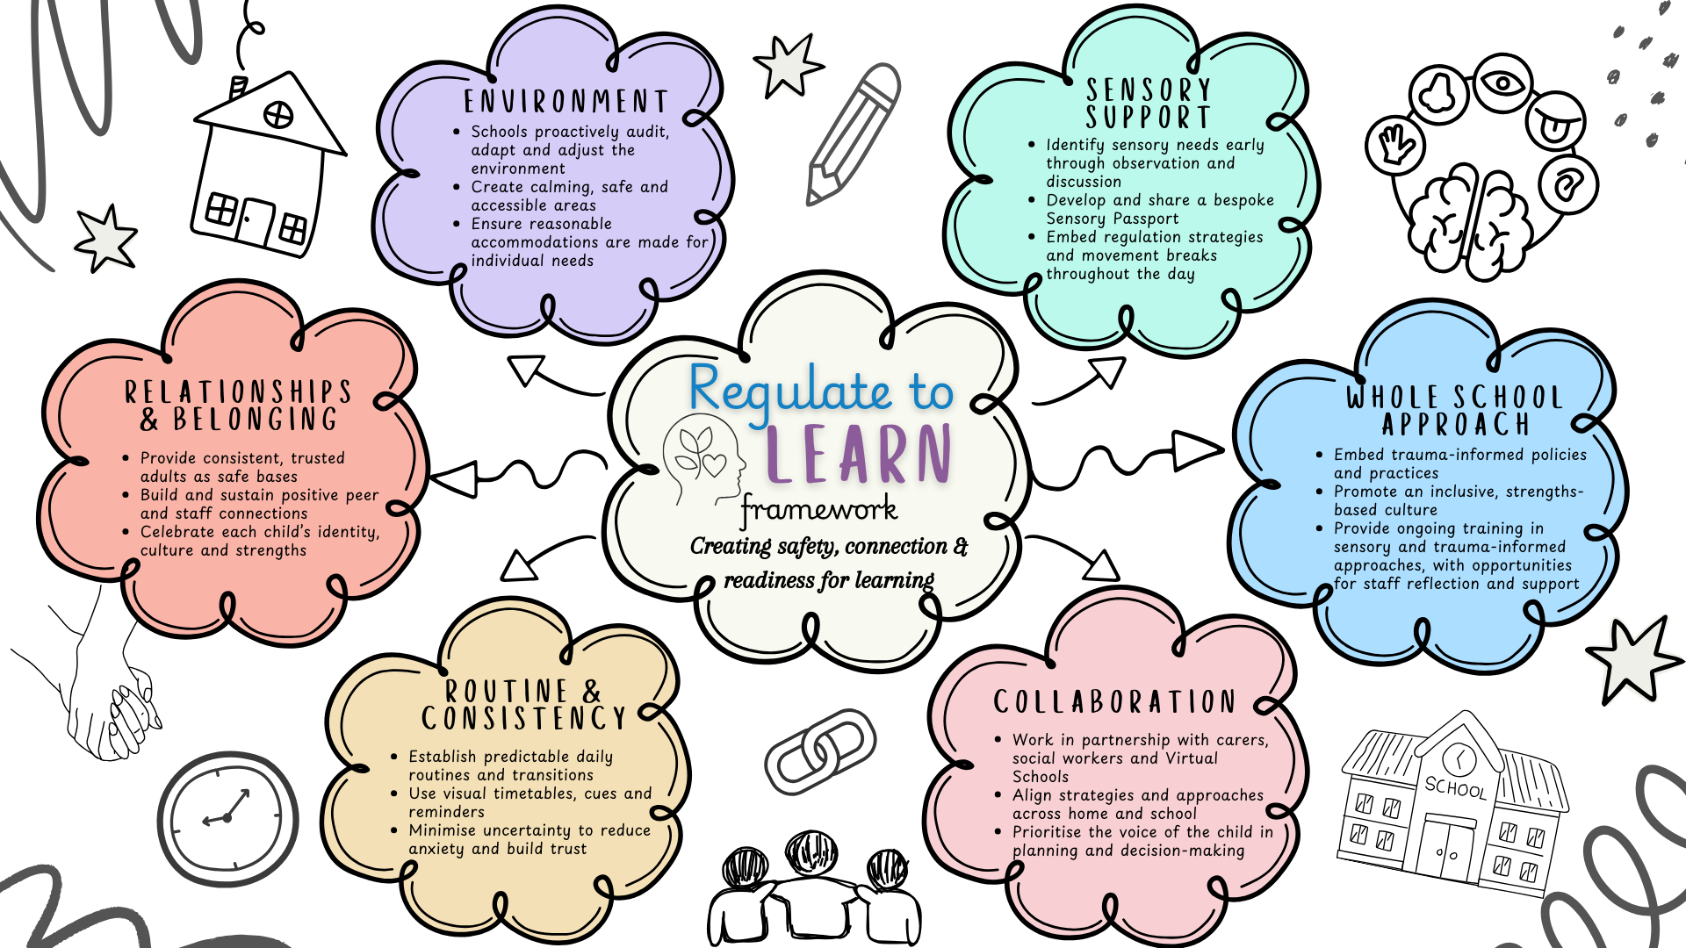
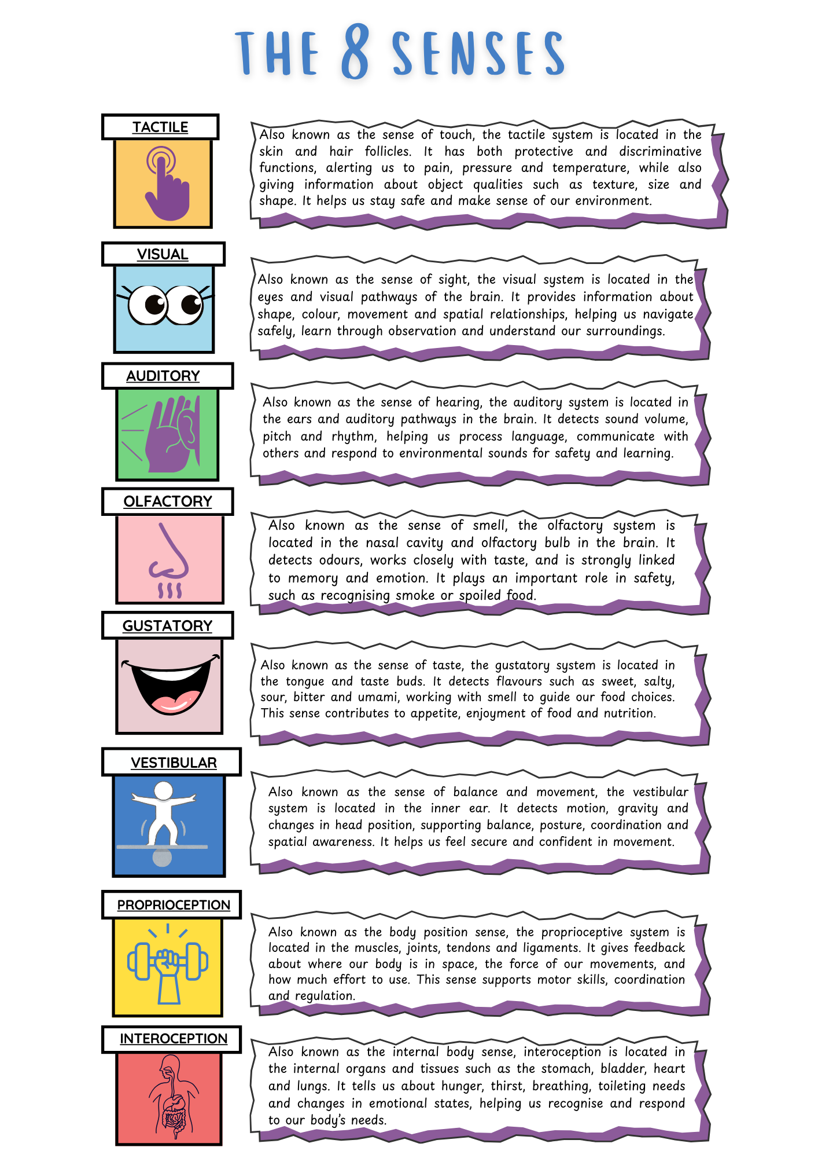

We all have little ways of managing sensory input throughout the day. Most of us do it without even thinking- like turning down the radio when driving through a busy roundabout so we can concentrate, or stepping outside for fresh air when a room feels stuffy. These small adjustments help us stay regulated and comfortable.
For some children, though, making sense of sensory input isn’t so easy. Everyday sights, sounds, smells or movements can feel confusing, overwhelming, or even distressing. This can affect how they think, feel and behave- and may show up in how they play, learn, look after themselves, or build friendships.
Often, there are patterns in how a child responds to sensory input. Noticing those patterns is the first step to understanding what’s really going on beneath the behaviour. The Regulate to Learn Toolkit is designed to help school staff and caregivers spot these patterns and use practical strategies, so that children have the best chance to feel safe, take part in learning, and connect with others.
Trauma & Sensory

Children who have lived through trauma are often hypervigilant- often on high alert for danger. This can make their senses extra-sensitive, so things that feel normal to most people can feel overwhelming or even threatening to them.
In school, this might show up as a strong reaction to loud noises, sudden movements, or just the everyday busyness of a classroom. For a hypervigilant child, these experiences can trigger stress, making it hard to concentrate, feel safe, or connect with others.
By recognising this and making simple adjustments, adults can ease the sensory load and help these children feel calmer and more secure. The strategies in the Regulate to Learn Toolkit are designed to support staff in creating environments where children’s sensitivities are understood, and where they are more able to focus, learn, and build positive relationships.

“Sensory Seeking” or “Seeking Safety”?
When we look at behaviour through a sensory lens, we often fall back on traditional terms like Sensory Seeking (needing more sensory input) or Sensory Avoiding (needing less sensory input). We then choose strategies based on whether a child seems to want more or less of a particular sensation.
But for children who’ve experienced developmental trauma, this way of thinking can miss something important. Their behaviour might not simply be about “more or less” sensory input — it might be about moving towards feeling safe or moving away from perceived threat. When we reframe behaviour this way, we begin to ask a different question: What does this child need to feel safe in their body right now?
Take this example: a child is always on the move- running, climbing, struggling to sit still, and often leaving the classroom. At first glance, it looks like classic seeking movement behaviour. Traditionally, you might assume they’re under-responsive to vestibular input and provide even more movement opportunities.
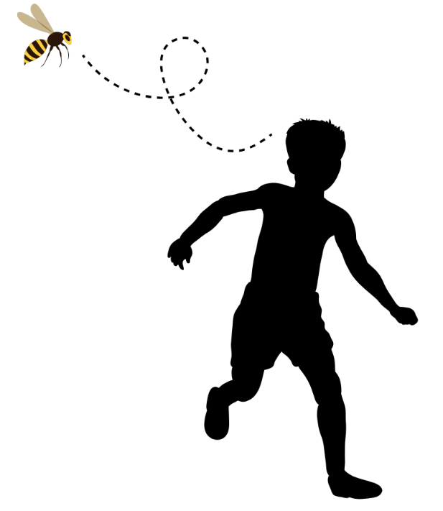
But imagine you spot something else: a wasp buzzing angrily around them. Suddenly, the behaviour makes sense in a new way. The child isn’t just “seeking movement”- they’re moving away from a threat. Their running is about control and safety, not under-responsiveness. In this case, would adding more intense movement help? Or would it make more sense to remove the wasp, reassure the child, and help them settle?
By shifting our lens from “more or less” sensory input to “safe or unsafe,” we gain a deeper understanding of behaviour. This allows us to respond in ways that are not only sensory-aware, but also trauma-informed and compassionate.

Stressors
Dr Bruce Perry and Oprah Winfrey, in their book What Happened to You? (2021), explain that not all stress is the same — and the type of stress children experience shapes whether they become more vulnerable or more resilient.
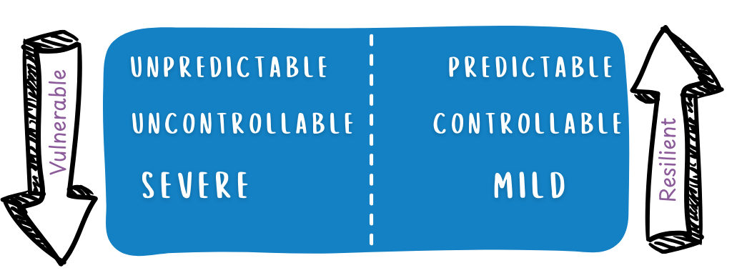
When stress is unpredictable, uncontrollable, or overwhelming, it can leave children feeling unsafe and powerless. For those who have experienced trauma, this kind of stress adds to anxiety and fear. If a child feels they have no control over what’s happening, it can deepen feelings of helplessness. Severe stress, such as violence or loss, can flood their system, making it harder to cope, learn, and build relationships.

But not all stress is bad. When challenges are predictable, manageable, and mild, they can actually help children grow. Knowing what to expect reduces anxiety, having some control builds confidence, and small, safe challenges give children the chance to practise coping skills. Over time, these experiences strengthen resilience and prepare them to face bigger difficulties.

For children who have lived through trauma, this difference is critical. Children looked-after, for example, often face instability such as moving between homes or schools. While the school day can provide some predictability, worries outside of school may still affect their sense of safety. This is why it’s so powerful when adults ask:
“How can I make today feel more predictable and manageable?”
Even small adjustments can help reduce overwhelming stress and build the foundations for resilience.

Under-developed Sensory Systems
Children who have experienced trauma or neglect may present with under-developed sensory systems. This is because the first three years of life are a crucial window for sensory development. During this time, babies and toddlers build their sensory foundations through safe, nurturing relationships and lots of everyday movement and play. Consistent touch, eye contact, sound, movement, and opportunities to explore the world all help wire the brain and body together. These experiences don’t just shape motor skills- they also lay the groundwork for attention, emotional regulation, and feeling safe in the body.
When children grow up without “good enough” care in those early years, these foundations may not fully develop. If a baby’s cries weren’t responded to, or if they didn’t get the chance to crawl, climb, or be soothed by a trusted adult, their sensory systems may not have had the input they needed. This can lead to gaps- for example, a child may be hypersensitive (everything feels too much), under-responsive (they don’t register sensory input), or struggle with balance, coordination, and self-regulation. These difficulties often become more noticeable as children grow older, when school life demands focus, sitting still, and managing emotions.
The good news is that it’s never too late. While the early years are a sensitive period, children can still strengthen their sensory foundations later in life. As Sarah Lloyd’s work on the BUSS model (Building Underdeveloped Sensorimotor Systems) highlights, we often need to “go back and fill in the gaps.” This means providing children with the kinds of nurturing, movement-based and sensory experiences they may have missed when they were younger. Simple activities that combine body movement, rhythm, balance, and safe connection with an adult can help to re-build these systems.
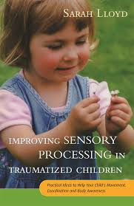
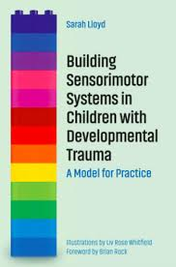
For teachers, SENDCos, and carers, this understanding is vital. Instead of seeing a child as “behind” or “difficult,” we can see them as needing opportunities to strengthen the foundations that were missed. By creating safe, structured chances to move, play, and connect, we help children regulate their bodies, feel safer in themselves, and unlock their capacity to learn. For more information on Under-Developed Sensory systems: The BUSS Model

Interoception & Trauma
Interoception is sometimes called the “eighth sense.” It’s what helps us notice and understand what’s happening inside our bodies- things like hunger, thirst, needing the toilet, feeling hot or cold, or noticing our heartbeat when we’re anxious. It also links closely to recognising our emotions, because feelings like anger, sadness or excitement all start with signals from the body.
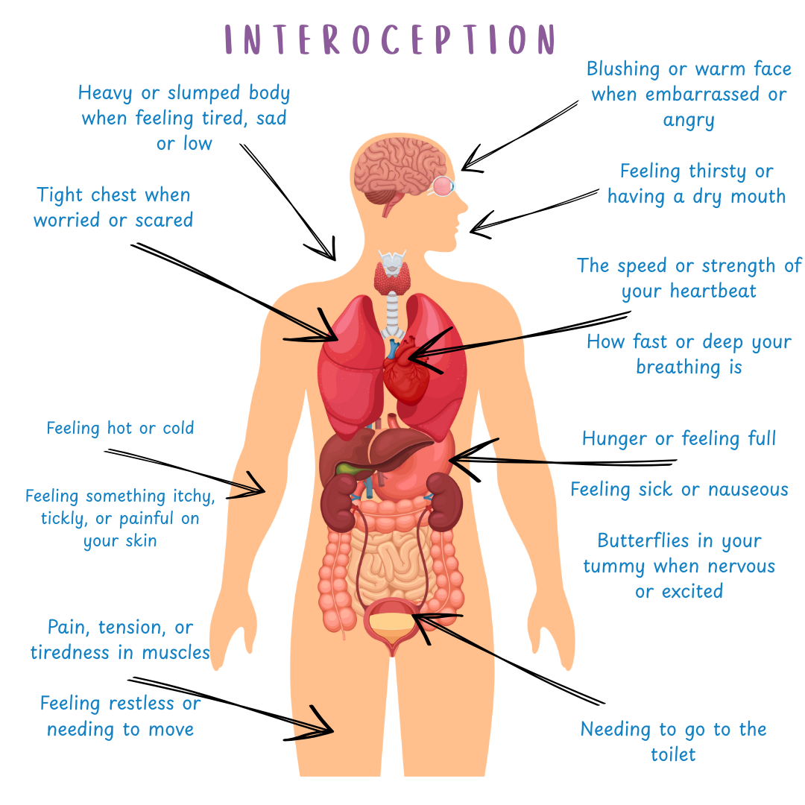
For children who have experienced trauma or neglect, their interoception can be impacted. In early childhood, babies learn about their internal signals when adults respond consistently to their needs- feeding them when they’re hungry, soothing them when they’re upset, changing them when they’re uncomfortable. Over time, these repeated experiences teach the child to connect the feeling inside their body with what it means and how to respond.
But when those early responses are absent, inconsistent or unsafe, children may not learn to trust or understand their body’s signals. This can show up as a child who doesn’t realise they’re hungry until they’re starving, who avoids going to the toilet until it’s urgent, or who struggles to name how they feel emotionally. Without this awareness, regulating emotions and behaviour becomes much harder.
Trusted adults can play a vital role in helping children rebuild these skills. Teachers, carers and support staff can make a big difference by:
- Noticing and naming body signals (“I wonder if your tummy’s rumbling.. could you be hungry?”).
- Offering gentle prompts (“It’s been a while since break, would you like a drink?”).
- Validating feelings (“I can see you’re fidgety… sometimes that means our body needs a stretch.”).
- Creating routines that give children predictable chances to check in with their body’s needs.
With patience, empathy and consistent support, children can gradually strengthen their interoceptive awareness. This helps them to trust their own bodies, understand their emotions more clearly, and build the foundations for healthier regulation and wellbeing.

For activity ideas that support with developing interoception awareness, please refer to the Regulate To Learn: Strategies guide

Trauma-Compassionate Approach
The Neurosequential Model of Therapeutics (NMT), developed by Dr Bruce Perry, helps us understand how trauma and neglect impact a child’s brain. The brain develops from the bottom up- starting with the brainstem (basic survival), then the limbic system (emotions and relationships), and finally the cortex (thinking, reasoning and learning).
When children experience trauma early in life, development can get disrupted. Instead of feeling safe enough to use the “thinking brain,” many children spend much of their time operating from the survival part of the brain- the brainstem. This is why we may see “big behaviours”: explosive reactions, hypervigilance, or withdrawal. It isn’t that the child won’t engage in learning, it’s that at a biological level they can’t - because their brain is stuck in survival mode.
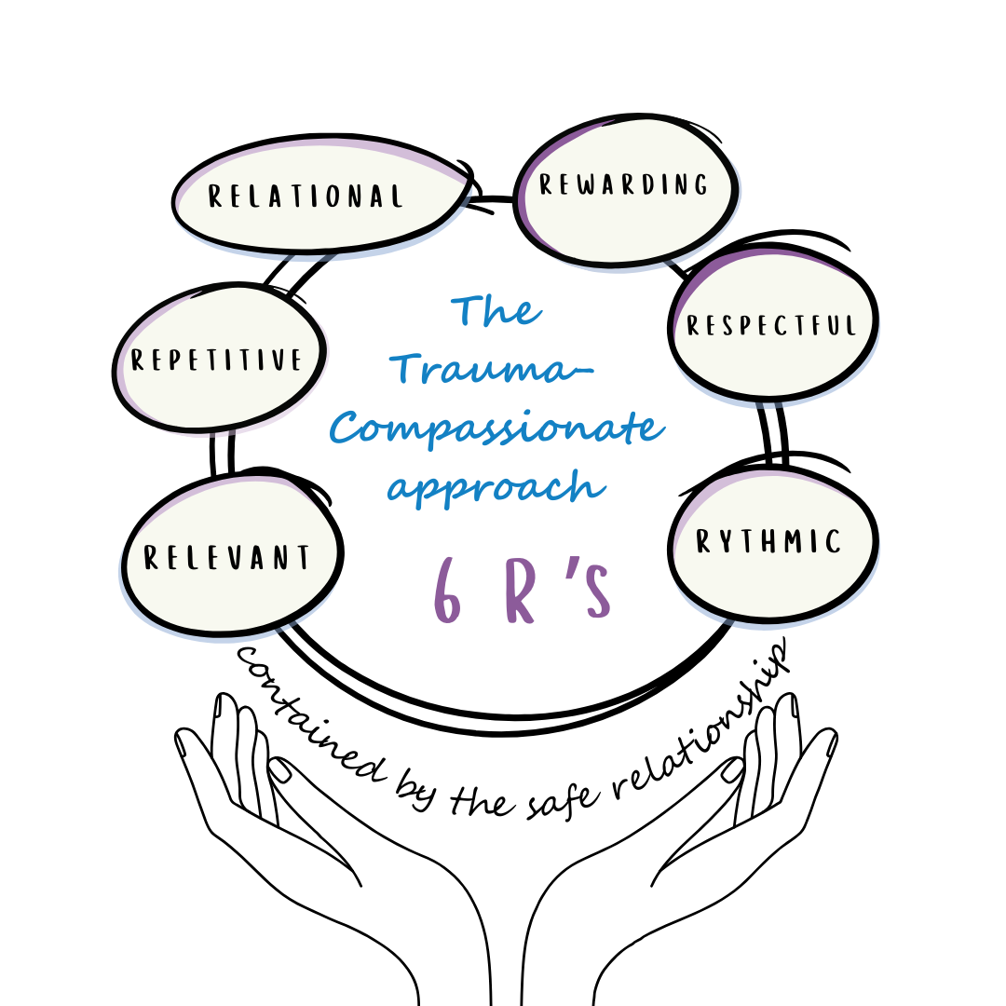

To support our children, we need to calm the lower parts of the brain first, before expecting them to reflect, reason or learn. This is where the 6 R’s from NMT are so helpful when choosing activities or strategies:
- Rewarding – enjoyable, so children want to repeat them
- Relevant – meaningful and suited to the child’s needs and interests
- Relational – built around safe, trusting connections with others
- Rhythmic – using steady patterns (like rocking, drumming, walking) that help to engage the brainstem and regulate the nervous system
- Repetitive – repeated often to strengthen brain pathways and provide consistent “safe patterns”
- Respectful – always done with sensitivity, choice, and dignity
By using activities that follow these principles- like rhythm games, movement breaks, or relational play, we give children what their brains need to feel safe and regulated. From there, they are more able to engage with the “thinking brain,” making reflection, learning and positive relationships possible.

Neurodiversity & Trauma

When supporting children who have experienced developmental trauma, it can be tempting to search for answers in a diagnosis or a label. Staff may find themselves asking: Is this autism? Is it ADHD? Is it attachment? While these questions are understandable, they can sometimes distract us from the bigger picture: the child in front of us, with their unique strengths, challenges and needs.
Children’s behaviours are often the result of many overlapping factors. Trauma, attachment, and neurodivergence can all shape how a child engages with the world- and often there isn’t a neat dividing line. Focusing too much on “which box does this fit into?” risks missing what the child is really communicating.
The more helpful question is:
“What does this child need to feel safe, regulated and ready to learn?”
From this perspective, the priority is not a label but a plan. Support strategies like:
- Consistent, predictable routines that reduce anxiety
- Trusting relationships with adults who provide warmth and stability
- Sensory regulation opportunities that help the child manage their body state
- Inclusive teaching practices that make space for diverse learning needs
These are strategies that benefit all children, but they are especially powerful for those who carry the impact of trauma.
A whole-child approach encourages us to be curious rather than certain. Instead of assuming behaviour means one thing or another, we reflect:
- What might this behaviour be telling us?
- What experiences may have shaped how this child responds to the world?
- What can we adapt- in ourselves, our classroom, or the environment, to help this child succeed?
By shifting the focus away from labels and onto the child’s lived experience, we create space for compassion, flexibility and creativity. This mind-set not only supports children with trauma histories but helps build classrooms where every child feels seen, understood and supported to thrive

(PDF) The Coventry Grid Interview (CGI): exploring autism & attachment difficulties. Good Autism Practice, 18, 1, 62-80

For children whose difficulties are thought to be linked to neurodiversity and perhaps related to a sensory processing need (rather than trauma/attachment) it may be beneficial to use the Rotherham Sensory Toolkit which is available on the Rotherham Local Offer (Under Health & Wellbeing, 11. Sensory Needs): Health and Wellbeing – Rotherham SEND Local Offer

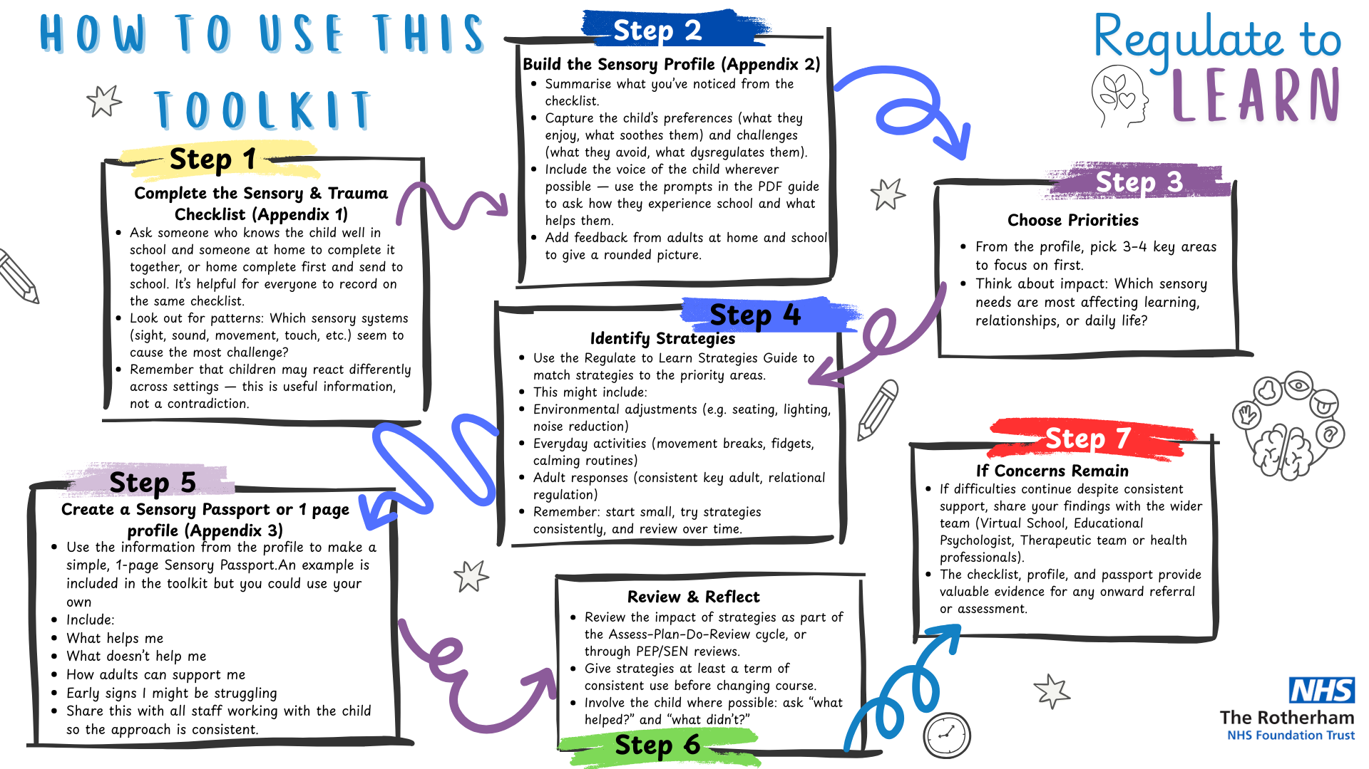

Useful resources

https://www.rotherhamsendlocaloffer.org.uk/health-wellbeing/sensory-needs
Rotherham Local Offer - information and advice on sensory needs
Rotherham Virtual School: Host training events and offer support and advice for children looked after
https://sensoryladders.org/ - Free online training for using sensory ladders as a sensory regulation tool
https://sendcorotherham.co.uk/sensory-needs/ - Rotherham SEND website. Practical ideas and strategies to support sensory needs.
https://www.nhsggc.org.uk/kids/life-skills/joining-in-with-sensory-differences/ - NHS Glasgow Sensory website. Lots of information, videos and advice to support sensory challenges
https://beaconhouse.org.uk/ - Fantastic website full of therapeutic resources and advice.
www.sensorypie.com – Sensory & Trauma consultation, training, and resources
www.creativetherapies.com – Seminars, workshops and resources on Sensory & Trauma by Marti Smith
Kelly Mahler's Interoception Training: Boost Body Awareness – All things interoception

Books
- Success with sensory supports by Kim Griffin
- Building Sensorimotor Systems in Children with Developmental Trauma – Sarah Lloyd
- Sensory Healing after Developmental Trauma by Marti Smith
- Transforming Trauma in Children & Adolescents: An embodied approach to somatic regulation, trauma processing & attachment building’ (Warner, Wescot et al 2020)
- Sensory circuits: A sensory motor skills programme for children by Jane Horwood
- Settling to learn by Louise Michelle Bomber and Daniel A Hughes
- Interoception and Regulation by Charlottle Brownlow
- The Scared Gang Series [Box Set of 9 books] – The Scared Gang books by Éadaoin Bhreathnach, Occupational Therapist
- Our Stories | Piplo Productions – Stories and ebooks for children who have had adverse experiences

Videos to illustrate sensory differences experienced by children:

https://youtu.be/hWP5YNXRCTY?si=l-hezBb_53IXe4uE – Introduction to understanding sensory needs
https://www.youtube.com/playlist?list=PL0t2dRFWj648bfg1aVONrjioeb05GD8fm
NAS video collection
https://youtu.be/e6swX6SvRLc?si=sBOYKRpvWHEWhave – Sensory Memories (Beacon House)
https://youtu.be/K2P4Ed6G3gw?si=-vHHj6xqHHaMYchp – Sensory Overload
@STARInstitute (youtube) – Playlists and videos on sensory processing

Appendix 1 –
Trauma-Informed Sensory Checklist

Trauma-Informed Sensory Checklist
A framework for Primary Schools (age 5-11)

The following checklist is not a diagnostic tool. Rather, it is an indicator of sensory needs related to developmental trauma. The purpose of the tool is to gather information related to a child’s or young person’s sensory profile. This will assist in creating an action plan and passport bespoke to the individual child’s needs.

Child’s name |  | DOB |  | Setting

Completed by
Name |  | Relationship to child |  | Date
Name |  | Relationship to child |  | Date

The checklist is designed to be used by people who know the child well (school and home). Children may present with different sensory behaviours in different environments so it’s important to consider the responses over a range of environments. It’s important to consider that children may be able to tolerate sensory input if they are in a highly motivating situation and general wellbeing can affect a person’s ability to tolerate sensory information.

Please discuss the statements below, tick the box that best fits the child and add comments as appropriate.
If school and home are completing on the same checklist, please differentiate between school and home view (eg; use different colours)

Any sensory responses are to be considered in light of typical developmental patterns.

Tips for Completing The Sensory Checklist

- Observe in Natural Settings: Carry out observations in various environments where the child spends time, such as the classroom, playground, dinner hall, and during transitions. This provides a comprehensive view of their sensory responses in different contexts. Caregiver to highlight on the checklist their responses within the home environment.

- Include Multiple Perspectives: Gather input from various sources, including teachers, teaching assistants, parents/ foster carers, and the children themselves when possible. This holistic approach ensures a more accurate and well-rounded assessment.

- Consider current transitions/ circumstances for child: During periods of change (ie; change of caregiver, new school, new classroom, new teacher/ TA, change of care circumstances, holidays, family contact) children may present more hypervigilant and sensitive to the sensory environment. Children may need time to adapt to new routines and adjust to the environment so that a more accurate sensory picture can be built.

- Dysregulation may not always appear as ‘big’ behaviours: Refer to the observation of state chart below to support with observing regulation states.

 | Seeks this experience / enjoyable | Integrated State  Neutral | Hyper-aroused  Dysregulated / Anxious
Body Movement & Action | - Movement/Engagement appears purposeful and confident or unconscious/auto-pilot  - Activity may involve repetition or be rhythmic in nature  - Child may appear ‘zoned out’ or in a ‘mesmerised’ state  - May appear in a state of flow / loses track of time and awareness of what is happening around them.  - The child may actively seek this out or engage in behaviours that result in experiencing this  - The action may be routine and specific (the child seems to know exactly what to do themselves without adult support)  - Strong desire to engage | - Energised and active or calm and alert body movements  - Grounded, co-ordinated  - Posture, arms, legs are co-ordinated  - Actions are directed, controlled, fluid  - Able to organise self – shows plan, sequence or follow through in actions  - Intent clear to others  - Aware and engaged with environment and others  - Body physiology is in-sync with activity eg; breathing heavier with exertion, breathing slower when relaxed  - Appears soothed or comforted by the activity, may request to do the activity again.  - Is able to concentrate and focus on task in hand. | - Disjointed & disorganised  - Impulsive  - Appears random, compulsive, unregulated  - Rapid pacing, jittery, muscle tension, trembling  - Moving excessively  - Bouncing from thing to thing  - Little or no follow through  - Intent unclear  - Appears responsive/ hyper vigilant to sensory environment  - Laboured or rapid breathing  - Fast heart rate  - Looks flushed or pale  - May be actively avoiding the situation by running away, trying to reduce or avoid input  - Struggles to follow direction, respond to instructions or connect with others
Emotional presentation | - The child often appears in control though sometimes excitement can escalate to dysregulation.  - The child may appear calm/ relaxed  - The child may appear excitable / happy / energetic  - May be motivated by reward of this activity/experience  - May seek adult or peer connection through this activity | - Consistency of pitch & loudness of voice, facial expressions and gestures  - Matches activity or narrative  - May recognise and respond to emotions in others  - May name own emotions  - Open to connecting with others, engages in conversation, can process verbal instructions, asks questions, may have a smile, may be laughing, engaged, alert and on task, is able to ask for advice during the task or seek support from adult. | - Reactive, explosive  - Distracted, anxious  - Emotions not clear or readable  - Voice may be loud, unmodulated  - Non-verbal grunts, throaty sounds  - May seek out connection from a trusted adult or engage in behaviours to be closer to a specific adult
Body Awareness | - Aware of specific body parts or sensory systems which are being activated by the activity/ experience.  - Lead by sensation, will often continue the activity until they feel ‘just right’  - If sharing the experience with others, may feel more connected to them emotionally.  - May ask for more or ask for this experience/ input. | - Aware of body in space  - Uses visual/ tactile information to navigate environment without bumping into people or objects  - Adjusts (or attempts to adjust) pressure or intensity to activity  - May be able to notice thirst, fatigue, body temperature and other body signals  - May be aware of pain and physical sensations | - Poor awareness of body in space  - Seems oblivious to others  - Runs into objects, unaware of environment, unaware of danger  - Seems not to notice or respond to thirst, fatigue, body temperature etc.  - May not show awareness of pain
Adapted from ‘Transforming Trauma in Children & Adolescents: An embodied approach to somatic regulation, trauma processing & attachment building’ (Warner, Wescot et al 2020)

No. | Item |  | Typically presents calm |  | Integrated stated/  Neutral |  |  |  | Typically finds this challenging |  |  | Notes/Observations:  Does the child present hyper-aroused/dysregulated  OR  Do they find the experience enjoyable? Can this lead to ‘over-arousal’/excitement?
Visual Sensory System
Try to observe or think about a time the child has experienced the following visual inputs. Please include extra notes to expand on your thoughts if necessary.
 | Bright lights/ bright environments
 | Presentation when trying to find an item in a visually busy environment e.g.; locating certain clothing in a drawer, finding bag in the cloakroom
 | Presentation when engaging in visual discrimination activities e.g.; where’s wally books, dobble, spot the difference, jigsaws, sorting items.
 | Presentation in visually busy places e.g.; cloakroom, assembly, lunch hall
 | Presentation when sat by nearby visual stimuli (pictures, items on walls, windows, other children)
 | Wearing a hood, peaked hat or sunglasses
 | Reading independently
 | Presentation when in dim environments (tents, darkened rooms, cinema etc.)
 | Presentation when around spinning, flashing or pulsing lights
 | Presentation when using technology/ screens
 | Looks intensely at objects and/or people does the child present as calm or anxious if demonstrating this behaviour.
Auditory Sensory System
Try to observe or think about a time the child has experienced the following auditory inputs. Please include extra notes to expand on your thoughts if necessary.
No. | Item |  | Typically presents calm |  |  | Integrated stated/  Neutral |  | Typically finds this challenging |  |  | Does the child present hyper-aroused/dysregulated  OR  Do they find the experience enjoyable? Can this lead to ‘over-arousal’/excitement?
 | Presentation during loud sounds (slamming door, fire alarm, hair dryer, toilet flushing, hand dryer) |  |  |  |  |  |  |  |  |  | Describe what happens
 | Presentation at the sounds of singing or musical instruments
 | Making repetitive sounds or own noise to block out other sounds.
 | Presentation when in quiet spaces |  |  |  |  |  |  |  |  |  | Describe how the child presents
 | Presentation in noisy and busy places eg; cloakroom, playground, shopping centres.
 | Presentation when faced with sounds others may not notice (hum of lights, electronics, clock ticking, traffic, fridge etc.)
 | Raised voices (eg; teacher raising voice, peers shouting)
 | Presentation during sudden sounds (fire alarms, ambulance, door slam)
 | Presentation during high pitch sounds (babies crying, puppies barking)
 | Presentation when making noises, especially in the kitchen / bathroom / dining hall (these tend to echo so noises are amplified)
Tactile Sensory System
Try to observe or think about a time the child has experienced the following tactile inputs. Please include extra notes to expand on your thoughts if necessary.
No. | Item |  | Typically presents calm |  |  | Integrated stated/  Neutral |  | Typically finds this challenging |  |  | NOTES/OBSERVATIONS  Does the child present hyper-aroused/dysregulated  OR  Do they find the experience enjoyable? Can this lead to ‘over-arousal’/excitement?
 | Presentation when hands or face are dirty (with glue, paint, food, dirt etc.).
 | When touching certain textures. |  |  |  |  |  |  |  |  |  | Describe the calming textures the child enjoys, or textures the child avoids.
 | When experiencing accidental or unexpected touch of others
 | Presentation when in crowded areas (eg; lining up, cloakroom, assemblies)
 | When experiencing light touch eg; hair ruffles, kisses, hand on shoulder, tickles.
 | When offered new foods to try
 | Presentation when engaging with personal care activities (hair washing/brushing, teeth cleaning, nail cutting)
 | Presentation when wearing clothes that have noticeable tags, labels and seams or are made from itchy/alerting materials e.g; wool, lace.
 | Presentation when barefoot
 | Presentation when offered hugs or holding hands
 | Presentation when wearing tight clothes
 | Presentation when experiencing noticeable hot or cold temperatures (e.g. touching windows or radiators)
 | Presentation when engaging in fine motor tasks
Vestibular Sensory System
Try to observe or think about a time the child has experienced the following vestibular inputs. Please include extra notes to expand on your thoughts if necessary.
No. | Item |  | Typically presents calm |  |  | Integrated stated/  Neutral |  | Typically finds this challenging |  |  | NOTES/OBSERVATIONS  Does the child present hyper-aroused/dysregulated  OR  Do they find the experience enjoyable? Can this lead to ‘over-arousal’/excitement?
 | Presentation when experiencing heights, even ones which are not particularly high e.g. small wall, standing on a chair, feet being off the floor.
 | Presentation when sitting on the floor |  |  |  |  |  |  |  |  |  | In what position does the child sit? Do they hold this position well?
 | Presentation when sitting at a desk for learning |  |  |  |  |  |  |  |  |  | In what position does the child sit? Do they hold this position well? What are their feet doing? How long can they typically sit for?
 | Presentation when walking on an uneven or unstable surface
 | Presentation when experiencing movement that signals nausea (travelling, spinning movements)
 | Presentation during PE |  |  |  |  |  |  |  |  |  | Is the child engaged and following instructions?  Do they struggle with keeping up / co-ordinating body?  How do they present following PE?
 | Presentation during ‘free play’ opportunities e.g: in the playground, at parks |  |  |  |  |  |  |  |  |  | Notice how the child is moving their body  Are movements fluid, purposeful/ confident?  Are movements jerky, uncontrolled?  Are the childs gross motor skills in line with their peers?
 | Presentation at a park or soft play |  |  |  |  |  |  |  |  |  | Which equipment is the child drawn to? What do they avoid?
 | Presentation during a car journey
 | Presentation when head is inverted (being upside down, handstands, hanging upside down off furniture)
Proprioceptive Sensory System
Try to observe or think about how often you notice the following behaviours..
No. | Observation |  | Frequently |  |  | Sometimes |  | Rarely |  |  | Notes/Observations
 | Falls out of chair when seated at desk or table
 | Runs, hops, skips or bounces instead of walking
 | Driven to seek out activities such as pushing, pulling, lifting and jumping.
 | Finds it difficult to apply the correct amount of pressure for tasks e.g. writing too light or too dark, gauging how to pour at the correct flow and amount.
 | Likes wrestling and squashing others / rough & tumble
 | Walks on toes, heavy footed or stamps
 | Seeks body feedback eg; Crawling under cushions, being in tight spaces, Enjoys being tightly wrapped in a blanket/towel.
 | Asks for hugs / hugs very tightly
 | Chews objects
 | Clumsy and bumps into objects and people (Does not seem to know where body is in space)
 | Seems to apply too much force for everyday tasks, may slam doors / cupboards.
 | Likes wearing clothes that offer feedback to the body – layers, weighted vests, tight leggings, compression wear, heavy jackets, hoods.
Smell Sensory System
Try to observe or think about a time the child has experienced the following smell inputs. Please include extra notes to expand on your thoughts if necessary.
No. | Item |  | Typically presents calm |  |  | Integrated stated/  Neutral |  | Typically finds this challenging |  |  | NOTES/OBSERVATIONS  Does the child present hyper-aroused/dysregulated  OR  Do they find the experience enjoyable? Can this lead to ‘over-arousal’/excitement?
 | Smells of others
 | Smell of certain environments |  |  |  |  |  |  |  |  |  | Which smells does the child specifically struggle with at home and at school?
 | Smells most people find offensive
 | Unfamiliar smells
 | Bathroom smells
 | Smells that remind them of individuals (Family, memory smells) |  |  |  |  |  |  |  |  |  | Are there any certain smells that evoke memories for the child? Have you noticed any specific smells that cause distress?
Taste Sensory System
Try to observe or think about a time the child has experienced the following taste inputs. Please include extra notes to expand on your thoughts if necessary.
No. | Item |  | Typically presents calm |  | Integrated stated/  Neutral |  |  |  | Typically finds this challenging |  |  | NOTES/OBSERVATIONS  Does the child present hyper-aroused/dysregulated  OR  Do they find the experience enjoyable? Can this lead to ‘over-arousal’/excitement?
 | Presentation when trying intense flavours, spice, salts, sweet and sour
 | Presentation when eating or chewing materials which are not edible
 | Presentation when offered foods they’ve not tried before |  |  |  |  |  |  |  |  |  | Child’s preferred or favourite foods?  Make any comments here regarding child’s diet.
 | Presentation when offered food that is either ‘too hot’ or ‘too cold’
 | Presentation when brushing teeth
 | Presentation when eating in a social situation (eating with family, eating with friends during lunch) |  |  |  |  |  |  |  |  |  | Does the child typically eat less or more during social eating?
Signs of differences with interoception (processing internal sensation)
No. | Observation |  | Struggles to identify sensation (might forget, not notice or easily ignore the sensation) |  |  | Neutral |  | Sensitive to this sensation (recognises it intensely or pre-occupied by sensation) |  |  | Notes/Observations
 | Feeling of hunger
 | Feeling of fullness after a meal
 | Feeling of thirst
 | Needing to use the toilet to urinate
 | Needing to use the toilet to defecate
 | Body temperature (recognising when hot/ cold)
 | Feeling fatigued or tired
 | Identifying and recognising emotions
 | Feeling of physical pain
 | Feeling of illness
Signs of under-developed sensory systems
No. | Observation |  | Frequently |  |  | Sometimes |  | Rarely |  |  | Notes/Observations
 | Movements appear jerky, un-controlled, wobbly or floppy (even when calm/regulated)
 | Moves around the environment either too quickly or too slowly, struggles with careful co-ordinated movement. (even when calm/regulated)
 | Bumps into objects, furniture. Lots of crashing/banging movements. (even when calm/regulated)
 | Dribbles or drools / food falls out of mouth when eating / frequently spills food
 | Appears floppy, leans on walls/furniture
 | Relies on visual system to complete motor tasks eg; watches feet when walking down stairs, or peddling a bike
 | Stamps feet when walking
 | Trips and falls often, appears clumsy
 | Struggles to chew certain foods
SEMH - Signs of attachment needs
No. | Childs Perspective |  | Frequently |  |  | Sometimes |  | Rarely |  |  | Notes/Observations
 | I feel safest when I'm close to my teacher or teaching assistant, so I try to stay near them. Sometimes, focusing on my learning feels hard when I'm worried about whether they are still there for me.
 | I may adopt a character for interacting with others and my environment as a way of ensuring I feel emotionally safe.
 | I may feel alone and scared of not being held in mind.
 | I find it difficult to concentrate on learning because I need to feel safe alongside a trusted adult / key adult.
 | Concentrating and focusing can be tricky for me as I can’t help but to scan the environment for signs of danger.
 | I tend to think of adults or situations as either all good or all bad depending on how I feel in the moment.
 | I may project strong feelings onto adults of anger/hurt/ frustration/ despair/ fear
 | Friendships feel fragile for me so I want to hold on to them.
 | I may identify with other children who experience a sense of disconnection.
 | I can easily feel overwhelmed by shame.
 | Sometimes I might come across as controlling or needing to be in charge. This often happens when I feel afraid or uncertain—acting powerful can feel safer than showing I’m vulnerable
 | I might be described as being self -directed in terms of what I will do in class.
 | I can feel very wobbly at unstructured and/or unsupervised times.
 | I crave predictability, routine and consistency
 | I like to keep busy to keep separated from my thoughts and feelings as they can be overwhelming. Lack of structure means I have no control and puts me in a fearful state.
 | I may feel uncomfortable in my school due to reminders of my family and/or my past
 | Emotions can be confusing to me, I don’t always know how to identify and respond to my own or others feelings.
 | I feel sad. The depth of sadness I experience will likely overwhelm me at times.
 | I may have gaps in my knowledge of my educational journey.
SEMH – Transitions
No. | Observation |  | Frequently |  |  | Sometimes |  | Rarely |  |  | Notes/Observations
 | I struggle with morning transition – coming in to school and separating from my caregiver is really hard because of my previous experiences.
 | My emotions become overwhelming at the end of the day when its home time
 | I need time and adult support in the mornings to settle in to my learning.
 | I need encouragement to engage with current or next activities.
 | I find even little changes difficult to tolerate eg; 5 minutes left.
 | I can find change frightening and often worry it will always be bad.
 | I struggle to leave my old teacher and to start another year group.
 | When I’m asked to stop something I’m focused on, like during tidy-up time or the end of a lesson, it can feel really tough. I worry that I won’t be able to return to it later, and sometimes, that fear comes from past life experiences where promises haven’t been kept. This makes it harder for me to trust that I’ll get another chance.
 | I may need an adult to tidy up/ clear away with me as developmentally I have not had reliable experiences. I may be emotionally much younger in my learning skills due to my inconsistent early years.
 | I can seem impulsive because I find it difficult to wait.
 | I feel nervous and afraid if I do not have my familiar adults or people around me.
 | There are complicated reasons to why I feel anxious or afraid or unsettled when my typical school routine changes (eg; Christmas parties, sports day events).
 | My emotions become overwhelming at the end of the day when its home time
 | I can find it tricky to return to school after certain events eg; school holidays, following family time. I might feel confused and conflicted in my emotions.
Speech, Language & Communication
Childs Perspective |  | Frequently |  | Sometimes |  |  | Rarely |  |  | Notes/Observations
Sometimes when you ask me something, I don’t know what to say. I might say the question back to you or give an answer that doesn’t make sense because I’m trying to figure out what you mean or keep myself safe
I want to do what you ask, but it’s hard for me to understand all the steps of instructions or remember what to do next, especially if I’m feeling overwhelmed.
When I’m calm, I can listen and do what you ask. But when I feel stressed or upset, it’s like my brain can’t hear or remember your words anymore
Even when I’m really trying to listen, the words don’t always stay in my head. It can feel like they disappear before I understand what to do.
When I’m really upset, I can’t always find the words to tell you what’s wrong. I might show you with my body or actions instead.
When I feel really overwhelmed or unsafe, I go quiet. It’s not that I don’t want to talk—I just can’t in that moment.
My brain notices everything around me, and it’s hard to stay focused. Even small things can grab my attention or make me feel unsettled.
I want to have friends, but sometimes I don’t know how to join in, share, or take turns. If I feel unsure or hurt, I might walk away or act in a way that makes it hard to stay friends

What does the checklist tell us about the child’s sensory needs?
Review the checklist above by addressing each sensory section. What stands out most in each section? Consider all information, including views of caregivers and other adults who know the child to determine which sensory systems have related difficulties.

Where a child presents with a ‘mixed’ profile and it’s tricky to determine whether the child is over or under responsive, try not to focus too much on the label and more on what are the presenting needs and challenges within the environment.

Use the grids below to make notes or highlight key findings.
 | Typically presents calm | Typically finds this challenging | Signs of over-responsive behaviours | Signs of sensory-soothing behaviours
Visual
Auditory
Tactile
Vestibular
Smell
Taste

 | Differences in processing
Proprioceptive sensory system | Frequently answers:  0/12
Internal sensations (interoception) | Struggles to identify: 0/10  Sensitive to sensation: 0/10
Under-developed sensory systems | Frequently answers:  0/9
SEMH
Attachment needs | Frequently answers:  0/20
Transitions | Frequently answers:  0/14
Speech, Language & Communication | Frequently answers:  0/8

Sensory preferences:
What does the child enjoy? What do they find calming? What do they find stimulating? Don’t forget to include the voice of the child. Use the questions & prompts included in the Regulate To Learn guidance PDF

Sensory dislikes:
What can’t the child tolerate? What triggers undesired behaviours? Don’t forget to include the voice of the child, ask them what they find tricky about the school environment? Use the questions & prompts included in the Regulate To Learn guidance PDF

Appendix 2 -
Safety, Senses & Belonging Profile
Using the above information collected on the checklist (from both school and home) complete the below Safety, Senses & Belonging Profile to capture in one place the child’s sensory preferences and challenges for each sensory system as well as their preferences and challenges with relationships & sense of belonging. Don’t forget the voice of the child! Prompt questions have been included which can be used if helpful, please delete these prompts before completing the profile as this table is to capture ALL key information from school, parents/carers and the child.

_________________________’s Safety, Senses & Belonging Profile
Sensory System | Preferences  Sensory experiences the child seeks out, enjoys and calms | Challenges  Sensory experiences that challenge the child or challenge yourselves as a caregiver / teacher
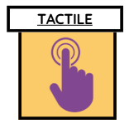 | - What things do you like to touch or hold when you’re in class?  - What kind of touch makes you feel calm? (eg; stroking soft fur, squeezing squidgy items, picking objects)  - What clothing feels most comfortable for you? | - Are there things in class you don’t like touching (paint, glue, sand)?  - Does it bother you when others are close to you? Like when you’re in the cloakroom or busy areas of school?  - Are there clothes or materials that feel scratchy or uncomfortable?
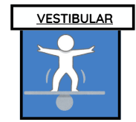 | - What kind of movements help your body to feel calm?  - Is there a way we can help make moving around school feel easier or safer for you?  - Do you feel better after you’ve had a chance to move? | - Are there any playground activities that feel too fast or wobbly for you?  - Is it hard to sit still for a long time?  - Do you sometimes feel dizzy or wobbly when moving?
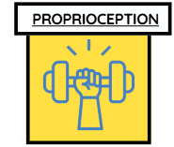 | - Does your body feel calmer after PE or playtime?  - Do you like being in small spaces?  - How do you feel about tight squeezy hugs?  - Do you like having a blanket on you or being wrapped tight? | - Do you find it tricky to keep your body co-ordinated sometimes?  - Is handwriting or fiddly work sometimes tricky or tiring? Does your wrist ever ache after handwriting?  - Do you bump into things or people without meaning to?
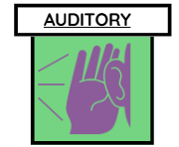 | - What sounds make you feel happy or calm at school?  - Do you like listening to music, stories, or certain voices?  - Are there times when you like it to be quiet? | - Are there noises in school that feel too loud or annoying that distract you from learning?  - Do you find it hard to concentrate when lots of people are talking?  - Are there any noises that make your ears hurt?
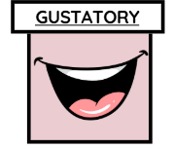 | - If you could only eat one type of food forever, what would it be – something crunchy, soft, chewy, or smooth?  - When you feel wiggly or upset, are there any snacks or drinks that help you feel better?  - Do you have favourite foods or drinks at school that make you feel good? | - Are there any foods that make your mouth feel funny, like too spicy, too tingly, or too strong?  - Are there foods at school you don’t like the taste of?  - Do you find it hard trying new foods at lunchtime?  - Tell me about the tastes you absolutely hate!..
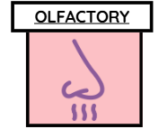 | - Do certain smells help you feel calm or happy?  - Can you think of a time when a smell made you feel good?  - Are there any smells at school that you really like? What do they remind you of? | - Are there any smells at school that you don’t like or that make you feel uncomfortable?  - Are there any places in school where the smells are too strong or make it hard to concentrate?  - Tell me about the smells you absolutely hate..
 | - What kind of books make you feel calm when you look at them?  - Do you prefer working with the lights bright or the lights dimmed?  - Is there a place you like to look at when you want to feel calm? | - Are there things in class that are too bright or distracting?  - Do you find it hard to look at the board or your work sometimes?  - What would you change about how the classroom looks?
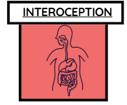 | - How do you know when you’re hungry or thirsty in school?  - What helps your body feel calm when you’re worried?  - What makes you feel comfy and ready to learn? | - Is it hard to notice when you need the toilet?  - Do you sometimes get tummy aches, headaches, or feel hot/cold quickly?  - Is it tricky to know what feeling you’re having (tired, worried, excited)?  - How do you know when you’re starting to feel? (angry/sad/upset/wobbly/whatever word the child uses)
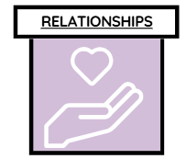 | - Who do you feel happiest or safest with at school?  - Is there a grown-up you like to go to when you need help?  - What kind of things can a grown up do to help you feel safe and calm? What would they say? | - Are there times when being around other children feels tricky (e.g. playtime, group work)?  - When you’re feeling upset, what kind of things do adults do that makes it worse? What would they say?  - What kind of things make you upset that other people do?
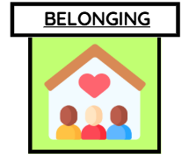  Belonging is the feeling of being accepted, included, and valued as part of a group. In school, it means feeling like an important member of the class and wider community.  For care-experienced children, this is especially important. Frequent changes in family, home, or school can leave them feeling different or unsure where they fit. When schools create a strong sense of belonging, children feel safer, more connected, and more able to learn, build trust, and form positive relationships. | Preferences / Strength Factors (things that help the child feel part of school)  - What helps this child feel included in the classroom or school community?  - Are there friendships, peer groups, or clubs where the child feels connected?  - Does the child enjoy being recognised or celebrated for achievements, identity, or interests?  - Are there school routines or traditions the child seems proud of or likes to join in with?  Voice of the child Questions:  - What helps you feel part of your class or school?  - Are there times you feel proud to be in your school? (e.g. assemblies, teams, clubs)  - Is there something about you (your culture, family, hobbies) that you’d like others to know or celebrate? | Challenges (things that may reduce the child’s sense of belonging)  - Are there times the child feels different, left out, or excluded by peers?  - Does the child struggle to join in with group activities, assemblies, or school events?  - Are there aspects of school life (uniform, rules, transitions) that make the child feel uncomfortable or highlight difference?  - Does the child express that they “don’t belong here” or avoid situations where belonging is important (e.g. group work, clubs, celebrations)?  Voice of the child Questions:  - Are there times you feel left out or different from the other children?  - Do you ever feel like you don’t fit in at school?  - Are there parts of school (assemblies, uniforms, groups) that make you feel uncomfortable or not yourself?

Appendix 3 -

Regulate to Learn Passport
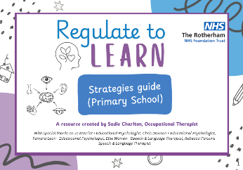
Now using all information gathered, and after reviewing the Ready to Learn Strategies guide, complete a one page profile or passport. There is a template below with prompts of what to include in each box. Once created (and agreed with the child) this can be shared with the team around the child and reviewed at key points throughout the year eg; Annual review, PEP, Transition to new class etc.


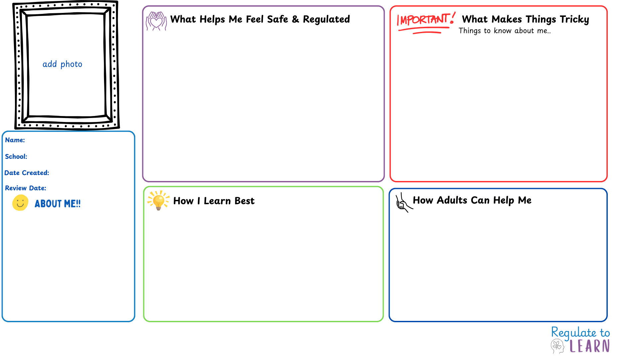
Everyday adjustments that support me:
How adults can help me regulate (what you can do/ say):
Ways to include me and build belonging:
What to do when I am struggling
Language to use (scripts, phrases to say)
Key adults in school:
Key adults outside school:
Sensory triggers (e.g. noise, busy spaces):

Situations that affect my sense of belonging:

Early signs I’m starting to struggle:

Phrases and situations I find triggering:

Sensitive topics that may upset me:

Challenging transitions or times of the day/ week:

Things that help me concentrate:

Things that make learning harder:

How I like to show what I know:

Environmental tweaks or adaptations

Sensory tools/resources that support me in the classroom

Sensory strategies that help me:

Trusted adults I can go to:

Spaces or activities that bring me calm:

Supporting with transitions:

Things I like / am proud of

My interests and hobbies

My favourite lessons and subjects at school

00/00/00
00/00/00
School
Name here

