Appendix 3 -

Regulate to Learn Passport
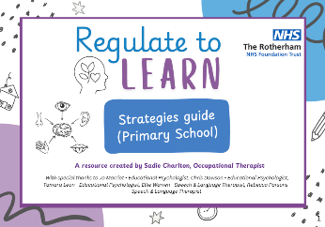
Now using all information gathered, and after reviewing the Ready to Learn Strategies guide, complete a one page profile or passport. There is a template below with prompts of what to include in each box. Once created (and agreed with the child) this can be shared with the team around the child and reviewed at key points throughout the year eg; Annual review, PEP, Transition to new class etc.


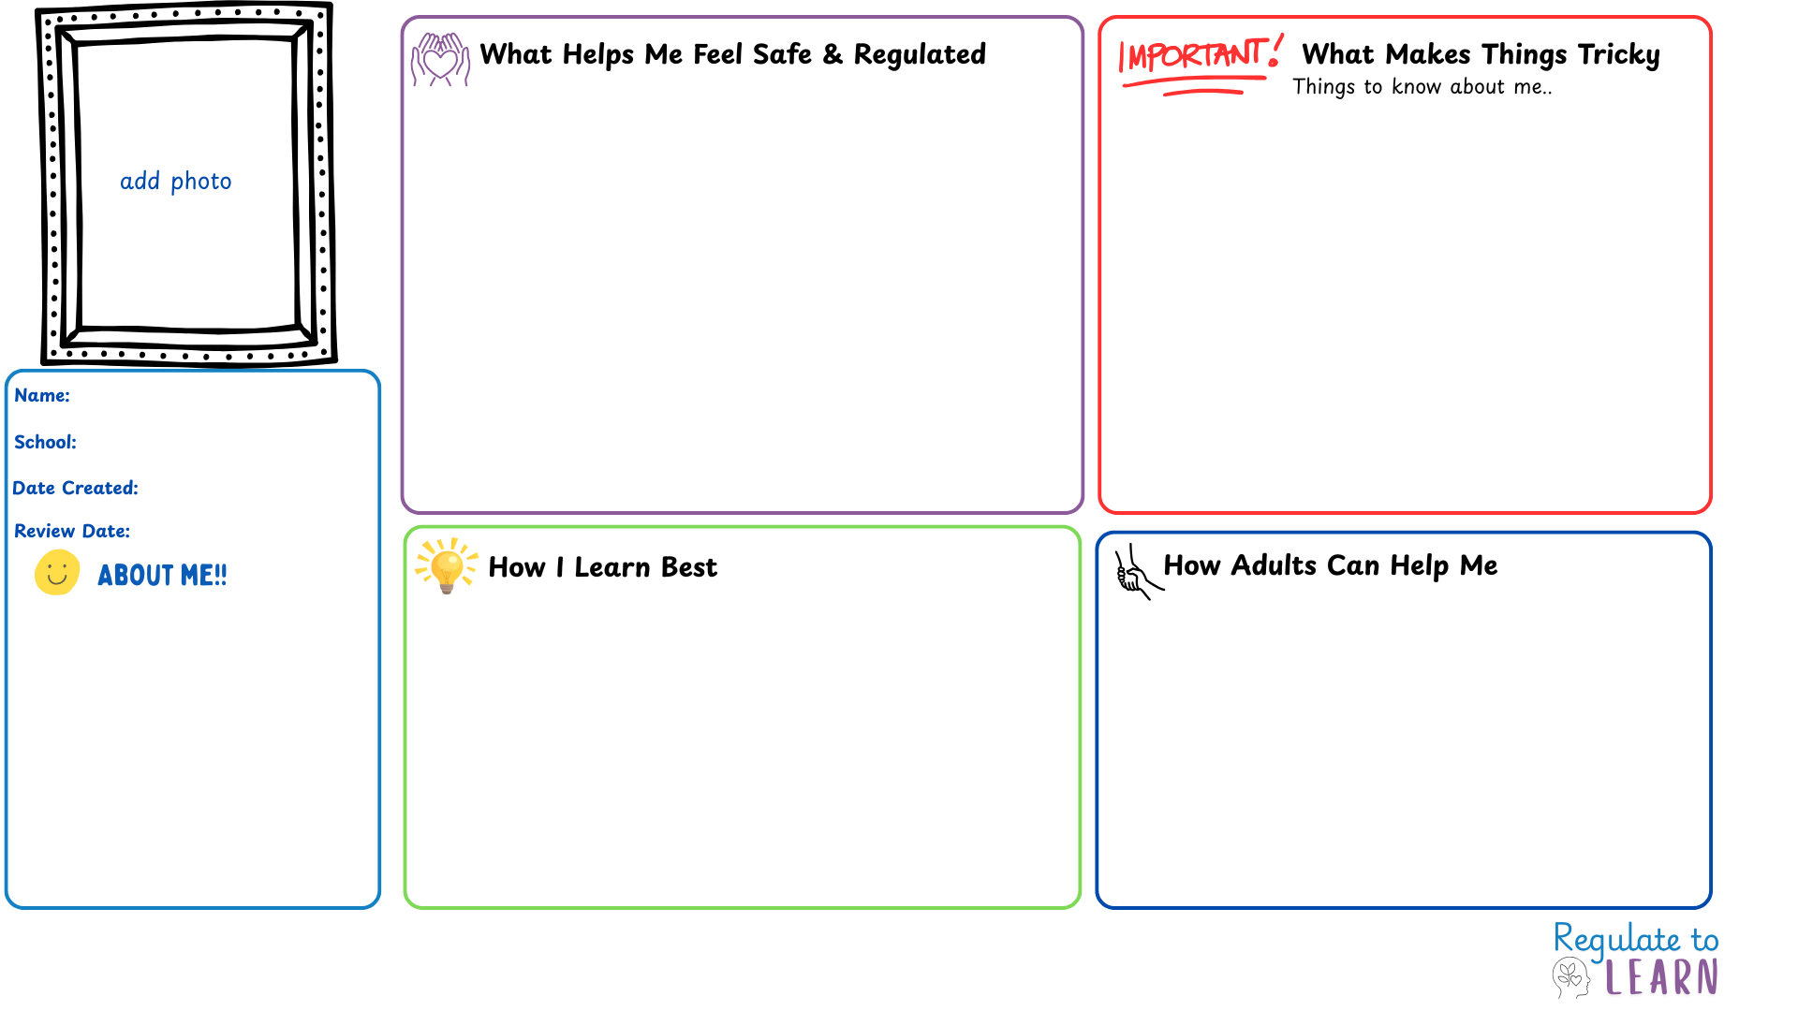
Everyday adjustments that support me:
How adults can help me regulate (what you can do/ say):
Ways to include me and build belonging:
What to do when I am struggling
Language to use (scripts, phrases to say)
Key adults in school:
Key adults outside school:
Sensory triggers (e.g. noise, busy spaces):

Situations that affect my sense of belonging:

Early signs I’m starting to struggle:

Phrases and situations I find triggering:

Sensitive topics that may upset me:

Challenging transitions or times of the day/ week:

Things that help me concentrate:

Things that make learning harder:

How I like to show what I know:

Environmental tweaks or adaptations

Sensory tools/resources that support me in the classroom

Sensory strategies that help me:

Trusted adults I can go to:

Spaces or activities that bring me calm:

Supporting with transitions:

Things I like / am proud of

My interests and hobbies

My favourite lessons and subjects at school

00/00/00
00/00/00
School
Name here

