Unacceptable behaviour classification

No incidents of unacceptable behaviour could be classified as low risk as any type of disruptive behaviour has the potential to cause an accident. So the following incidents of unacceptable behaviour are categorised under the two headings below:
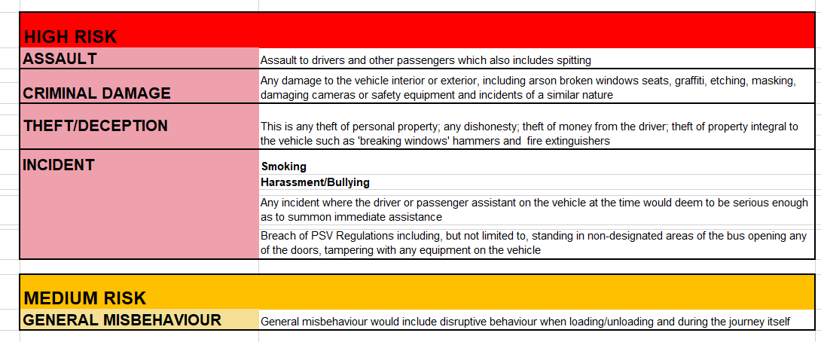
In addition, food and drink (other than water) is not permitted on any home to school transport journeys and access to the vehicle may be denied if a child/young person attempts to carry these onto transport.

RESPONDING AND REPORTING INCIDENTS
It is acknowledged that any operator has the right to exclude any passenger from travelling under their conditions of carriage. However, this guidance sets out a suggested partnership approach to managing such incidents in which the school has the leading role, in collaboration with parents/carers and the Local Authority unless there is to be a formal prosecution.

Responding to incidents of poor behaviour will depend into which risk category the behaviour falls. In each, there are possible recommended sanctions which can be applied to the offending pupil(s) although each case will depend upon its own circumstances.

The responses to the two risk categories are set out below. Unacceptable behaviour on transport may result in the withdrawal of assisted space on a vehicle operating to the child/young person’s place of education.

Repeated misbehaviour could well mean that the conduct of the pupil is automatically transferred to the higher category regardless of the specific incidents involved.

The responses to the two risk categories are set out below:

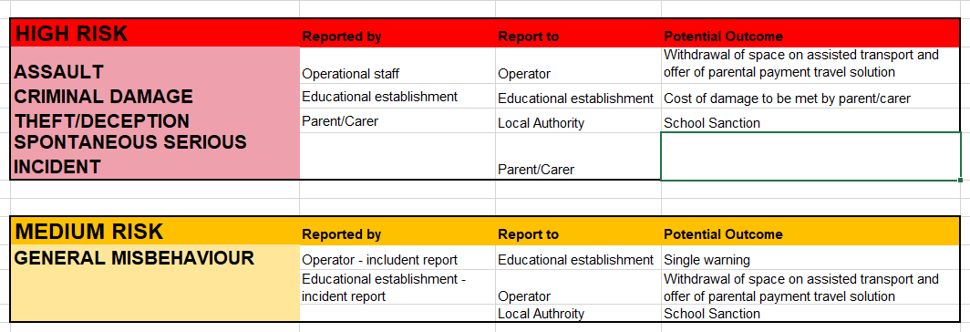

APPENDIX A

BEHAVIOUR CHARTER
The behaviour charter set out below is a condition of allocated space on a home to assisted transport provision organised by the Local Authority.

Non-compliance with the expectations contained within this charter may result in the withdrawal of assisted transport provision and replaced with a parental payment travel solution.

As a passenger on assisted home to school/college transport children and young people MUST:

- not assault or verbally abuse any other passenger or the driver.
- not commit or cause any damage to the vehicle including graffiti.
- not steal any item from other passengers or equipment from the bus.
- not smoke while on the bus.
- not harass any passenger or the driver or passenger assistant
- not engage in spitting.
- not open emergency doors or throw items from the bus.
- not use foul language or abusive gestures to other passengers, the driver, passenger assistant or occupants of other vehicles.
- not commit any other anti-social behaviour which could cause distress to other passengers or the driver.

APPENDIX B

e-mail: R&E-PassengerTransport@rotherham.gov.uk
RMBC TRANSPORT INCIDENT REPORT SHEET
Date/Time of Occurrence:

Name of Passenger:

Operator Name:

Route Name & Code:

Driver Name:

P.A Name: (where applicable)

Location of Occurrence:

Witness Details:
(Where Appropriate)

PLEASE USE THIS SHEET TO REPORT ANY INCIDENT YOU HAVE WITNESSED, SUCH AS CHILD BEHAVIOUR, MEDICATION OR STAFFING ISSUES, PARENT/CHILD ABSENT, ETC.

IF THERE IS A CAUSE FOR CONCERN, BUT YOU HAVE NOT WITNESSED AN ISSUE, FOR EXAMPLE SAFEGUARDING, YOU MUST FILL IN A CONCERN REPORT SHEET

OCCURRENCE TYPE: (Please Highlight)

Parent Absent Child Absent Child Late Child Behaviour

Medication Issue

Staffing Issue School Issue Vehicle Late Vehicle Failure

Other Issue

Road Traffic Collision (with passengers) Vandalism to Vehicle Equipment Issue

If ‘Other Issue’ please provide a description: ______________________________________________________________________________________________________________________________________________________________________________________________________________________________________________________

Please use the space below to indicate immediate corrective action.

Please use space below to provide a statement of facts, including all information and actions taken. Failure to provide full, clear details could result in this form being returned to you to resubmit further details.

Driver/Assistant/Operator Signature:

Received By: _______________________ __ Date:______________

Time:______________

