**Rotherham SEMH Strategy**

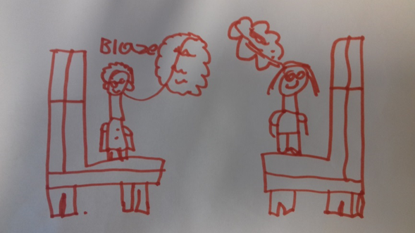

*All drawings by pupils at Hilltop school on the theme of what you can do if you’re feeling stressed/ unhappy*

**Introduction**

There is intense focus on meeting the needs of children and young people who need support to have good social, emotional and mental health. This terminology is used to describe children who have diagnosed mental health problems but is equally applied to those whose behaviour is triggering concerns about their overall wellbeing. Such a wide range of need cannot be met by a single organisation or be described using a simple pathway. There is a requirement for the whole system to mobilise to ensure that need is identified and met appropriately and as early as possible. This strategy will set out key priorities and actions that will enable work to be coordinated across the system, aligning the local response to key government strategies such as Future in Mind, with commissioning, sufficiency, workforce development and curriculum design planning. The goal is that, whether you are a child or young person, a parent or carer or a practitioner, your experience should be that there is no wrong door when it comes to meeting the needs of children who need support with social, emotional and mental health needs.

**The context**

Rotherham is not unique in being worried about how best to respond to growing concern about levels of social, emotional and mental health problems experienced by children and young people.

In 2018, the Prince’s Trust Macquarie Youth Index, which gauges young people’s happiness and confidence across a range of areas, found young people’s wellbeing was it its lowest level since the annual survey was launched in 2009. Four out of ten (39%) young people did not feel in control of their lives, two in ten (21%) felt their life would ‘amount to nothing no matter how hard they try’ and one in four (28%) said they would not ask for help if they were ‘feeling overwhelmed by something’.

In Rotherham, there has been a sharp increase in the number of children and young people who are being issued with an Education, Health and Care Plan, with social, emotional and mental health needs being identified as one of the most prevalent presenting needs.

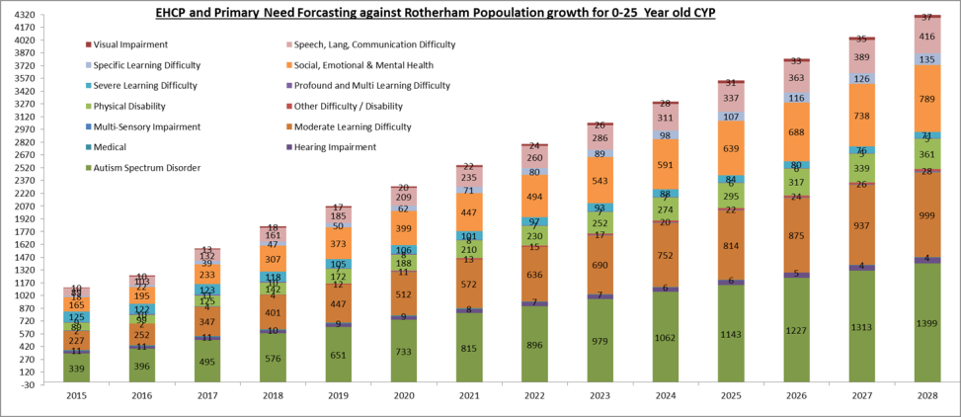

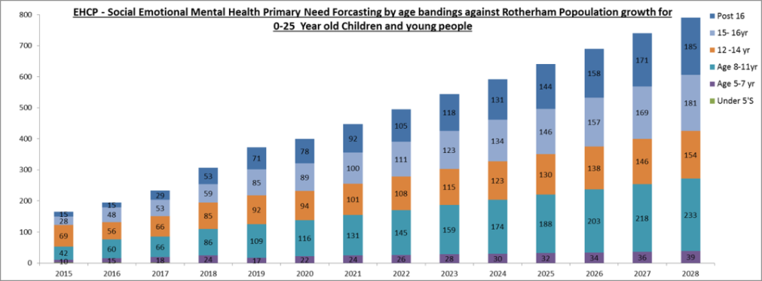

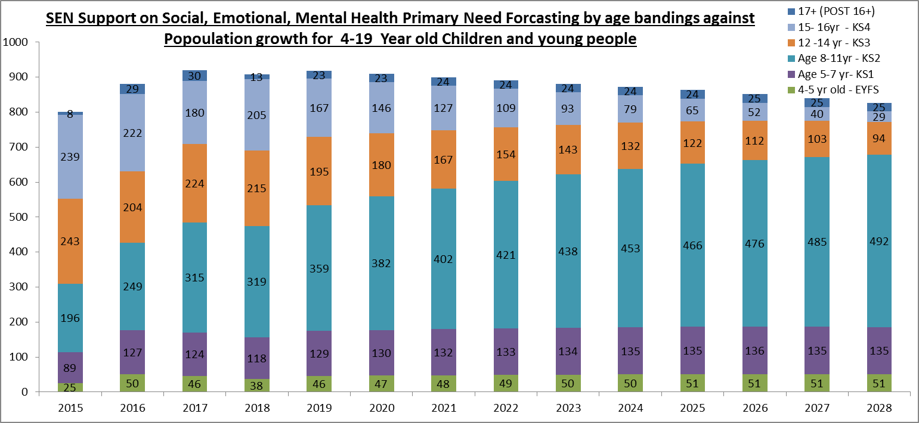

These graphs show that, as well as children with an Education, Health and Care Plan there are many who are registered for Special Educational Need Support in this category. If these increases in need are projected forwards using the existing trends and population data, the demand for services is likely to continue to rise. The school workforce experience is that there are many more children who are not represented in these graphs who need help and support.

“I don’t think the person you talk to needs to be a qualified counsellor or anything, it’s more important that it’s someone you trust and who gets you”

**The Policy Context**

In 2015, *Future in Mind*, the report of the Children and Young People’s Mental Health Taskforce (appointed by the Government in 2014), recommended local models with seamless pathways of care and support which recognised ‘the diversity of circumstances and issues with which families and young people approach mental health services.’ *Future in Mind* called for a fundamental culture shift, and set out a blueprint for a system focusing on prevention, early intervention and recovery, with the NHS, public health, local authorities, schools and youth justice working together to deliver joined-up services with easier to navigate care pathways.

In 2015 Rotherham published *Five Steps to Collective Responsibility* which outlined an approach to addressing the needs of children and young people with SEMH needs, with a focus on improving education provision. The principles identified in this strategy remain valid and relevant in 2019.

**Principles of Collective Responsibility for Children and Young People with Social Emotional and Mental Health (SEMH) difficulties**

* Be based on the equitable use of resources which is affordable, with realistic expectations and clearly defined outcomes
* Be a whole Borough response which is informed by transparent information and data and knowledge of local and national good practice;
* Recognise the importance of early intervention and be family and person centred;
* Recognise the importance of collective responsibility, which includes education, health and care partners and is based on a shared understanding of what is expected of all parties;
* Provide a graduated response with thresholds to prevent escalation into expensive out of borough provision;
* Provide local and flexible solutions which are developed and managed by schools;

In a similar timeframe, local delivery of Child and Adolescent Mental Health Services (CAMHS) has undergone a significant transformation. The *Local CAMHS Transformation Plan* was first published in October 2015, and is refreshed on an annual basis.

Alongside this, the local authority’s leadership of arrangements to fulfil the statutory responsibilities set out in *Working Together 2015* (refreshed in 2018) are now robust. The Ofsted inspection report published in January 2018, recognised Rotherham’s significant improvement journey; and Rotherham Children’s Services is now rated ‘good’. The improvement journey has included the implementation of a robust Early Help offer, and these arrangements can make a significant contribution to meeting the SEMH needs of children and young people.

**Governance and Accountability**

Partners are fully committed to working together to make decisions on a best for Rotherham basis to achieve the transformation. The Place Board provides governance to the Integrated Care Partnership Arrangements, including the delivery of the Local CAMHS Transformation Plan. Taking action to meet the social emotional and mental health needs of Children and Young People has also been identified as a priority for the Rotherham Strategic Education Partnership.

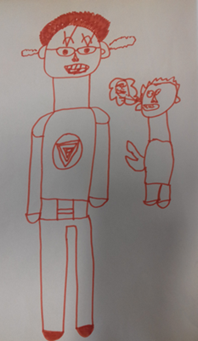

**Vision**

Rotherham meets the social, emotional and mental health needs of all children and young people through seamless access to the right services at the right time and a confident and resilient workforce

**Priorities**

1. **Sufficiency:** develop local education provision that responds to need – this will include flexible and specialist provision
2. **Seamless Pathways:** ensure that pathways to support are connected and aligned and develop a clear behaviour pathway that includes responses to attachment and trauma
3. **Partnerships:** develop and sustain robust inclusion partnerships that enable schools to meet need through a collective approach to responding to the needs of individual children
4. **Evidence-Based Approaches:** ensure that the local authority offer (from Early Help and Inclusion services) responds to need and is underpinned by evidence-based approaches and aligned with clear pathways
5. **Workforce:** develop a robust training and support offer, enabling practitioners to feel confident in responding to the needs of children and young people with SEMH needs
6. **Outcomes Focused and Value for Money:** ensure that all activity can demonstrate a clear outcome and value for money

“We need a healthy place to learn.”“Somewhere or somebody to go to if you’re feeling troubled- everybody should have that.”

**Rotherham Mental Health Trailblazer Pilot**

In December 2017 the Government published a Green Paper on children and young people’s mental health; proposals focused on early intervention and reducing the number of children and young people needing specialist services. The three core proposals emphasise the role of schools as a hub for mental health support:

* Development of mental health leads in schools
* Mental health support teams who are school based but linked into CAMHS
* A four-week waiting time standard for children and young people referred for mental health treatment

Rotherham and Doncaster submitted a joint bid to be part of wave 1 of the trailblazer and were successful.

**Mental Health Support Teams** (MHSTs) in schools will provide evidence-based early intervention and support for children and young people with mild to moderate mental health problems, and signposting to NHS and other appropriate services for further support.

**The Four Week Waiting Time Pilot** aims to reduce the waiting time from referral to treatment down to four weeks. The aim is to undertake assessment and formulation at receipt of request for support (day 1) and within seven days to have allocated the child or young person to the most appropriate clinician. Interventions will then commence within the subsequent three weeks. It is anticipated that the early intervention provided by the MHSTS will, in time, reduce demand for more specialist services and therefore contribute to this element of the trailblazer indirectly.

The diagram below illustrates the delivery model for the Mental Health Support Teams.

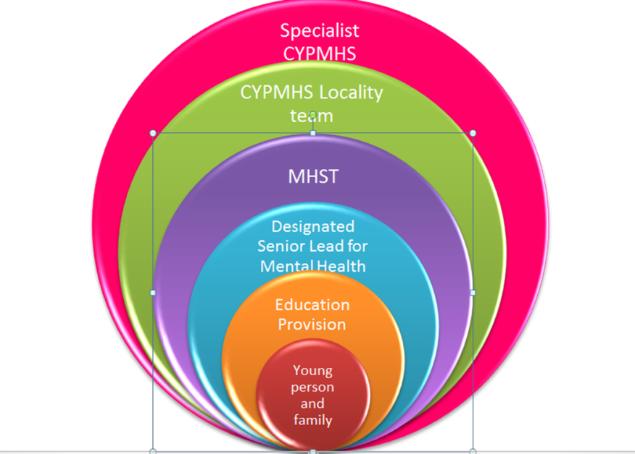

Rotherham’s Mental Health Trailblazer bid will provide direct insight to the social, emotional and mental needs of children in schools and how best to meet their needs quickly and effectively. This understanding will contribute directly to joint commissioning decisions and will enable us to achieve the priority of establishing seamless pathways to support.

“I used to get excluded a lot but its better now because I have a lead worker and I see him every day which helps, even though he is annoying, haha!”**What Does Success Look Like?**

Each year, a detailed action plan will be developed to identify the activity to support the priorities of this strategy. All activity will demonstrate how it will contribute to improved outcomes for children and young people. NHS England will develop a specific outcomes framework to evaluate the success of the trailblazer work.

However, the overall success of the strategy can be measured through the following criteria.

* A reduction in the number of permanent exclusions from all Rotherham schools
* A reduction in the number of referrals to Child and Adolescent Mental Health Services
* An increase in the confidence of the children’s workforce in responding to the needs of children and young people with SEMH needs

|  |  |  |  |  |
| --- | --- | --- | --- | --- |
|  | **Action** | **Progress updates** | **Target date** | **Owner** |
| 1. **Sufficiency: develop local education provision that responds to need – this will include flexible and specialist provision** | | | | |
| 1.1 | Develop robust SEND Sufficiency Data | Complete | October 2018 | RMBC Head of Inclusion |
| 1.2 | Share SEND Sufficiency Data with school partners | Complete | November 2018 | RMBC Head of Inclusion |
| 1.3 | Cabinet approval to use SEND Sufficiency Data to consult with schools | Complete | April 2019 | RMBC Head of Inclusion |
| 1.4 | School consultation events | Complete | May 2019 | RMBC Head of Inclusion |
| 1.5 | Bid submission and evaluation | Complete | May 2019 | RMBC Head of Inclusion |
| 1.6 | Develop timelines for successful bids | In Progress | July 2019 | Various leads; oversight by SEND Sufficiency Group |
| 1.7 | New provision becomes operational | In Progress | Phased approach September 2019 – September 2021 | Various leads; oversight by SEND Sufficiency Group |
| 1. **Seamless Pathways: ensure that pathways to support are connected and aligned and develop a clear behaviour pathway that includes responses to attachment and trauma** | | | | |
| 2.1 | Recruit Education Mental Health Practitioners | Complete | April 2019 | RDaSH CAMHS Service Manager |
| 2.2 | Training for EMHPs (including school placements) | In Progress | December 2019 | RDaSH CAMHS Service Manager |
| 2.3 | Appoint project lead for Mental Health Trailblazer | Complete | June 2019 | RCCG Commissioning Manager |
| 2.4 | Project Lead to visit all schools & audit current provision | In Progress | July 2019 | Rotherham Trailblazer Project Lead |
| 2.5 | Mental Health Support Teams operational in schools | In Progress | December 2019 | Rotherham Trailblazer Local Reference Group |
| 2.6 | Review impact and learning of Mental Health Support Teams in schools | In Progress | April 2020 | RDaSH CAMHS Service Manager |
| 2.7 | Ensure a clear evidence base & outcomes framework to evidence good practice | In Progress | December 2019 | RDaSH CAMHS Service Manager |
| 2.8 | Implement clear governance structures to ensure that good practice is shared across the system | In Progress | December 2019 | Joint AD Commissioning, Performance & Inclusion |
| 1. **Partnerships: develop and sustain robust inclusion partnerships that enable schools to meet need through a collective approach to responding to the needs of individual children** | | | | |
| 3.1 | Establish a task and finish group to review and develop Alternative Provision arrangements in Rotherham, including additional outreach support | Not Started | September 2019 | Joint AD Commissioning, Performance & Inclusion |
| 3.2 | Implement Primary Outreach Team, linked to Aspire provision (funding arrangements already agreed) | In Progress | September 2019 | RMBC Head of Inclusion |
| 3.2 | Ensure that Rotherham’s Pupil Referral Units are fit for purpose:  Complete a best value review  Review governance arrangements  Review pupil numbers  Agree funding arrangements  Agree pathways for multi-agency support  Review designation and re-designate where appropriate  Map pathways in and out of Pupil Referral Units | In Progress | November 2019 | Joint AD Commissioning, Performance & Inclusion |
| 3.3 | Agree accommodation strategy for Alternative Provision | Not Started | January 2020 | Joint AD Commissioning, Performance & Inclusion |
| 3.3 | Identify options to support Secondary Inclusion Partnerships | In Progress | September 2019 | Joint AD Commissioning, Performance & Inclusion/ Head of Finance CYPS |
| 3.4 | Identify options to support Primary Inclusion Partnerships | In Progress | September 2019 | Joint AD Commissioning, Performance & Inclusion/ Head of Finance CYPS |
| 3.5 | Review impact of new Alternative Provision arrangements & refresh where necessary | Not started | July 2020 | Joint AD Commissioning, Performance & Inclusion |
| 1. **Evidence-Based Approaches: ensure that the local authority offer (from Early Help and Inclusion services) is underpinned by evidence-based approaches and aligned with clear pathways** | | | | |
| 4.1 | Establish an Evidence-Based Practice Hub in Early Help; ensure that the offer is clearly articulated and linked to pathways of support | In Progress | July 2020 | Service Manager, Early Help |
| 4.2 | Review Inclusion Services and agree evidence-based programmes of delivery for each team / service (linked to priority 5) | In Progress | September 2020 | RMBC Head of Inclusion |
| 4.3 | Map pathways for support with clear links to evidence-based practice and programmes (refresh of graduated response) | In Progress | November 2019  & refreshed July 2020 | RMBC Principal Psychologist |
| 4.4 | Ensure that evidence-based approaches are complementary across the system (Early Help, Inclusion, Education) (linked to priority 5) | Not Started | September 2020 | Joint AD Commissioning, Performance & Inclusion |
| 1. **Workforce: develop a robust training and support, enabling practitioners to feel confident in responding to the needs of children and young people with SEMH needs** | | | | |
| 5.1 | Recruit a dedicated workforce lead to review the SEND / SEMH | In Progress | October 2019 | RMBC Head of Inclusion |
| 5.2 | Undertake an audit of the existing training offer for SEND / SEMH as delivered by health, education and social care | Not Started | April 2020 | Joint Workforce Project Lead |
| 5.3 | Design a single point of access for all practitioners (health, education and social care) to training associated with Special Educational Needs and Social, Emotional and Mental Health Needs. | Not Started | April 2020 | Joint Workforce Project Lead |
| 5.4 | Identify any gaps in the current training offers, and recommend evidence-based models to underpin the Rotherham approach to responding to SEMH. | Not Started | July 2020 | Joint Workforce Project Lead |
| 5.6 | Design a training needs assessment to guide service users to access the right training | Not Started | April 2020 | Joint Workforce Project Lead |
| 5.7 | Ensure that the training offer is clearly articulated and supports the workforce to meet presenting need | Not Started | July 2020 | Joint Workforce Project Lead |
| 5.8 | Implement the new training model and monitor take-up and impact | Not Started | September 2020 | Joint Workforce Project Lead |
| 1. **Outcomes Focused and Value for Money: ensure that all activity can demonstrate clear outcomes and value for money** | | | | |
| 6.1 | Ensure a clear evidence base & outcomes framework to evidence good practice from Mental Health Trailblazer | In Progress | December 2019 | RDaSH CAMHS Service Manager & Rotherham Trailblazer Strategic Lead |
| 6.2 | Develop clear outcomes and milestones for CAMHS priority (part of Rotherham Place Plan) | In Progress | April 2020 | RCCG Senior Commissioning Manager |
| 6.3 | Develop an Inclusion Scorecard with clear outcomes and quality standards for all teams and services | In Progress | April 2020 | RMBC Head of Service, Performance & Quality |
| 6.4 | Refresh SEND sufficiency data and track impact against baseline data | Not Started | July 2020 | RMBC Head of Service, Performance & Quality |
| 6.6 | Collate outcomes data for SEND cohort (including SEMH) | In Progress | September 2020 | RMBC Head of Service, Performance & Quality |